Driving a motor… with Joysticks!

# **Description**

This tutorial is a guide for driving a Vex IQ Smart Motor with the Vex IQ Controller Joysticks

# **Instructions**

1. Look on the desktop for the Robot C icon. Select the “RobotC for Vex Robotics”  
   Do not open the “Graphical ROBOTC” program  
   1. 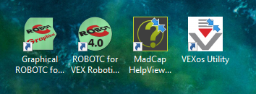
2. Open a new file and enter the following  
   1. 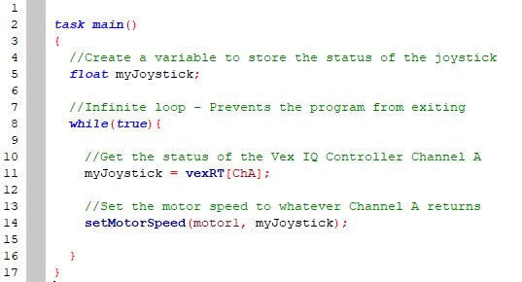
3. Compile, Download to Robot, and Start
   1.  🡪  🡪 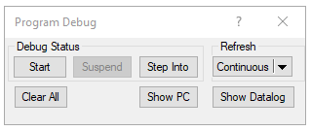
4. Test out Channel A on the joystick. See how it controls the motor!
5. Change the joystick axis and motor!
   1. Try using a different channel (ex. “ChB” or “ChD”)
   2. Try using a different motor (ex. “motor6” or “motor12”)
6. Add another joystick to control a different motor!
   1. Add another global variable for a second joystick
   2. Fill the second joystick variable with another vexRT[] channel
   3. Decide which motor to control with the second joystick
7. Use the following as a guide when selecting joystick channels:

